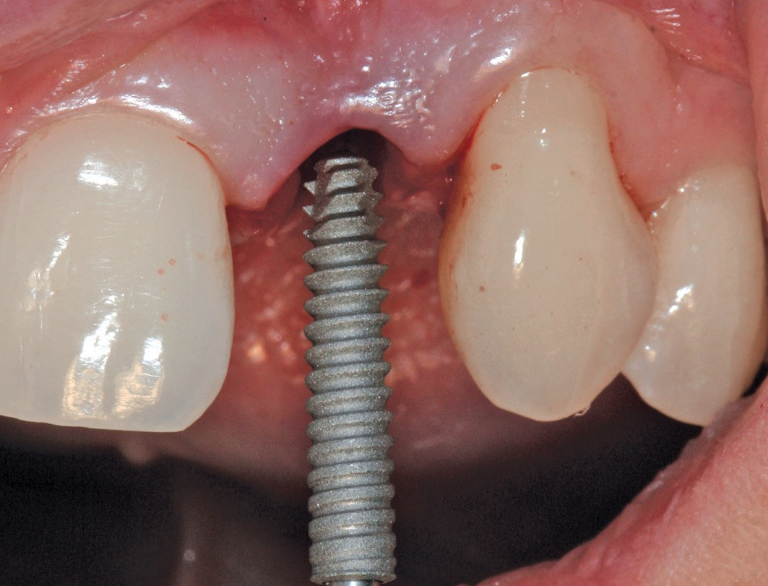Implant_24-1_Exbrayat - 22.1.2018 - 15:58 - page 49

SURGERY
Scientific Review

Clinical evaluation of the 2-part Axiom® 2.8
implants
Results 1 year post-treatment of a multicentre clinical study

P. EXBRAYAT
P. MISSIKA
P. RUSSE

Over the past 30 years, osteointegrated dental implants have proven to give very high
O
success rates in various clinical cases of edentulism. The wide range of dental implant diameters available on the market allows for adaptation to anatomical contexts.

Some difficulties have been encountered, however, for single-unit replacements in areas of reduced bone volume such as the mandibular incisors and some maxillary lateral incisors. Small-diameter implants are available on the market, but when the dimensions are larger than 3 mm and the implant groove is narrow, they are less suitable for
3

IMPLANT 2018;24:49-61 49

single-unit replacement. Implants with a diameter less than or equal to 3 mm were, until now, only available in a single-component version, and therefore required immediate temporisation and sometimes in-mouth rectification of the crown part.
The Axiom® 2.8 (Anthogyr-France) implants combine a reduced diameter with a two-part configuration. They are designed with the same specifications regarding the materials used (Ti-6Al-4V titanium alloy), and the surface finishing, as the other implants that Anthogyr has been producing for many years. They feature a conical compressive connection. This connection provides high dynamic strength that is superior to that of competitor implants used in this type of indication (FIG. 1).

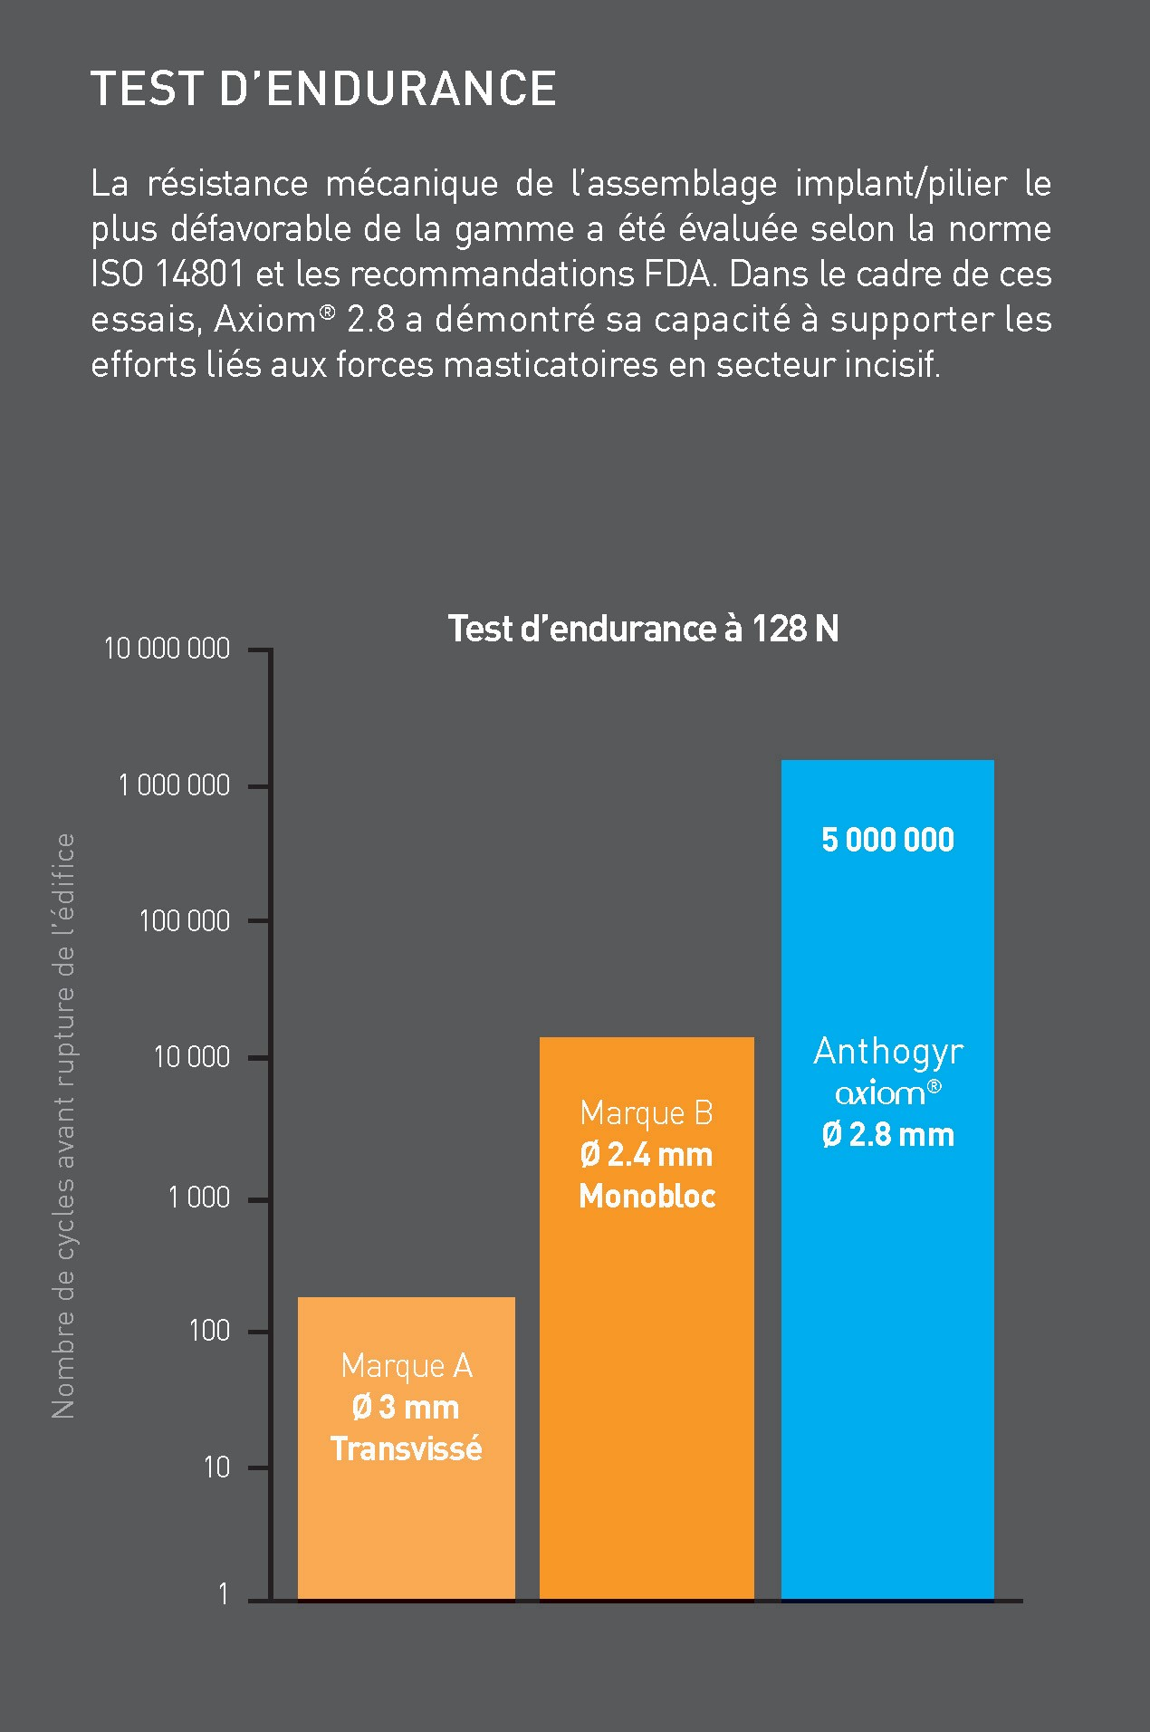
F_{IG}.1/ Results of the comparative dynamic tests carried out by Anthogyr.
A non-interventional multicentre clinical study has been conducted in France and Switzerland to evaluate the clinical effectiveness of this narrow, two-part implant for the single-unit replacement of mandibular incisors or maxillary lateral incisors.
The aim of this multicentre study is to evaluate the clinical success and reliability of the Axiom® 2.8 implant over a 5-year period. This article presents the results from the one-year interim evaluation. A 3-year evaluation is also scheduled.

MATERIAL AND METHODS
Five investigative centres and eight practitioners took part in this study:
- Pr Patrick Missika/Dr Hervé Tarragano/Dr Philippe Russe: Faculty of dental surgery in Paris VII- Denis Diderot, Department of Implantology;
- Dr Patrick Exbrayat: Dental practice in Lyon;
- Dr Patrick Limbour/Dr Jérémie Perrin: Faculty of dental surgery in Rennes, Department of Implantology;
- Dr Abdessamad Boukari: Faculty of dental surgery in Strasbourg, Department of Implantology;
- Pr Jean-Pierre Bernard: Faculty of dentistry in Geneva, Department of Implantology.
The implants were all placed by experienced implantologists. This study was submitted to the Ethics Committee in Geneva.
Cylindrical, 2-part screw-retained Axiom® 2.8 (Anthogyr, Sallanches-France) implants made of grade V titanium, with a rough BCP and acid-treated surface and a compressed internal conical connection were used in this study and restored with single-unit ceramic-metallic or ceramic-ceramic crowns.
Thirty patients were included in the study, 24 of whom were followed for 1 year following the treatment they received. They will be re-examined at 3 years and 5 years after treatment. At each follow-up stage, the investigators performed a retro-alveolar x-ray, an occlusal view image and a vestibular view image. The following criteria were evaluated:
- implant stability:

  - bleeding index;
  - peri-implant probing depth;
  - patient satisfaction.
Bone level measurements taken from the x-rays were performed by an independent evaluator using the Kinovea software. The measurement scale on the x-ray was calibrated using the known length of the implant (FIG. 2). The bone loss corresponds to the difference between the bone level measured at the start of the study (bone level at the start of treatment) and that measured 1 year after treatment.
The average bone level was calculated between the mesial and distal levels.

RESULTS
Twenty four patients were followed for 1 year following the start of treatment. The average age is 40.
Implants with a length of 14 mm were the most frequently used (FIG. 3 and 4); 66% of the crowns are ceramic-metallic and 34% are ceramic-ceramic.

IMPLANT STABILITY ASSESMENT
Eleven implants out of the 21 measured show bone gain. On 3 implants the bone level is identical at the start of treatment and 1 year after the start of the
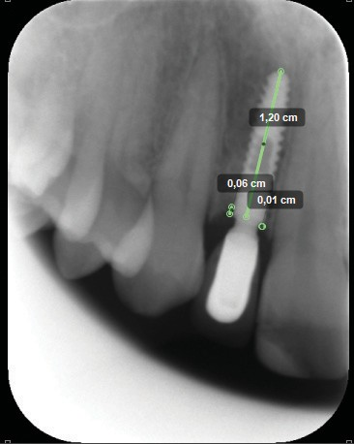
treatment. Six implants show bone loss between 0 and 1 mm. One implant shows bone loss greater than 2mm (TABLE 1)

BLEEDING INDEX 1 YEAR POST-TREATMENT
Nineteen implants have a bleeding index equal to0, and5 implants have a bleeding index equal to 1
(TABLE 2).

PROBING DEPTH 1 YEAR POST-TREATMENT
This probing depth measurement will be valuable when compared with the results at 3 and 5 years (TABLE 3).

PATIENT SATISFACTION
One year after implant placement, 100% of patients were very satisfied or satisfied with the treatment received.(FIG. 5).
14 mm
12 mm
10 mm
15

10

5

0
F_{IG}.3 / Length of implants placed.
12
10
8
6
4
2
0
12 14 22 31 32 41 42
F_{IG}.4 / Position of the implants.

17 %

Very satisfied

83 %

Satisfied

F_{IG}.2 / Mesial and distal bone level measurements 1 year post-treatment.
F_{IG}.5 / Patient satisfaction 1 year post-treatment. 3

T_{ABLE} 1/ Average bone loss 1 year after treatment.

Patient No. | Mesial bone level versus platform | Distal bone level versus platform | Average bone level versus platform | Mesial bone level | Distal bone level | Average bone level versus platform | Bone loss
1 | - 0.30 | - 2.00 | - 1.15 | 0 | 0 | 0 | 1.15
2 | 0 | 0 | 0 | -0.7 | - 1.10 | - 0.90 | - 0.90
3 | - 2.00 | 0.30 | - 1.15 | -2.00 | 0.50 | - 0.75 | 0.40
4 | 1.00 | 0.50 | 1.25 | 1.00 | 0.50 | 0.75 | - 0.50
5 | - 0.50 | - 0.50 | 0.50 | 1.00 | 1.00 | 1.00 | 0.50
6 | - 4.50 | - 0.39 | - 2.445 | 0 | 0 | 0 | 2.45
7 | 0.10 | 0.10 | 0.10 | 0.10 | 0.10 | 0.10 | 0
8 | 1.00 | 1.00 | 1.00 | 1.00 | 0.50 | 0.75 | - 0.25
9 | 1.00 | 0.50 | 1.25 | 1.00 | 1.00 | 1.00 | - 0.25
10 | 0 | 0 | 0 | 0.50 | 0.50 | 0.50 | 0.50
11 | 0 | - 0.50 | 0.25 | 0 | 0 | 0 | - 0.25
12 | - 0.70 | - 1.10 | - 0.9 | - 0.05 | 0 | - 0.03 | 0.88
13 | 0 | 0 | 0 | 0 | 0 | 0 | 0
14 | - 0.60 | - 1.10 | - 0.85 | - 0.60 | -1 | - 0.80 | 0.05
15 | - 2.10 | - 0.50 | - 1.30 | - 2.40 | 0.50 | - 0.95 | 0.35
16 | 0 | - 0.20 | - 0.10 | 0 | - 0.20 | - 0.10 | 0
17 | - 3 | - 4 | - 3.50 | - 1.00 | - 1.50 | - 1.25 | 2.25
18 | 0 | 0 | 0 | 0.50 | 0.50 | 0.50 | 0.50
19 | - 1.10 | - 1.5 | 1.30 | - 0.09 | - 1.50 | - 0.80 | - 2.10
20 | 1.00 | 1.00 | 1.00 | 1.50 | 1.50 | 1.50 | 0.50
21 | 0.9 | 0.90 | 0.90 | 0 | 0 | 0 | - 0.90
Average | - 0.47 | - 0.36 | - 0.18 | 0.02 | - 0.01 | - 0.01 | 0.21
Standard deviation | 1.42 | 1.15 | 1.25 | 0.97 | 0.83 | 0.74 | 1.00

T_{ABLE} 2/ Results of bleeding test by probing 1 year post-treatment.

Bleeding index | 0 | 1 | 2 | 3
Number of implants | 19 | 5 | 0 | 0
* 0: no bleeding when passing the probe / 1: visible isolated bleeding points / 2: bleeding forms a red line on the marginal gingiva / 3: heavy bleeding.

ADVERSE EVENTS
Only one implant had to be removed due to an early peri-implant infection and was successfully

replaced. No other reports of pain or signs of infection were observed 1 year post-treatment.

T_{ABLE} 3/ Probing depth 1 year post-treatment.

Patient | Vestibular | Mesial | Palatal /Lingual | Distal
1 | 2 | 2 | 2 | 2
2 | 1 | 1 | 1 | 1
3 | 2.5 | 2.5 | 3 | 4.5
4 | 1 | 1.5 | 1.5 | 1.5
5 | 1.5 | 2 | 1 | 2
6 | 2 | 2.5 | 3 | 4.5
7 | 2 | 1 | 3 | 3
8 | 3 | 4 | 2 | 4
9 | 1 | 1 | 1 | 1.5
10 | 1 | 2 | 2 | 3
11 | 0.5 | 1 | 1 | 1.5
12 | MD | MD | MD | MD
13 | MD | MD | MD | MD
14 | 0 | MD | MD | MD
15 | 1 | 1.5 | 1 | 2
16 | 3 | 2 | 3 | 2
17 | 2 | 2 | 1 | 2
18 | 2 | 2 | 4 | 2
19 | 4 | 4 | 4 | 4
20 | 2 | 2 | 2 | 2
21 | 6 | 4 | 4 | 4
22 | 2 | 3 | 2 | 3
23 | 2 | 2 | 1 | 3
24 | 1 | 2 | 1 | 2
N | 22 | 21 | 21 | 21
Average | 2.0 | 2.2 | 2.1 | 2.6
Standard deviation | 1.3 | 1.0 | 1.1 | 0.9
MD = missing data.

PRESENTATION OF 3 CLINICAL CASES
CASE No. 1 – Dr Philippe RUSSE (_{FIG}. 6 to 20)
Thomas, patient aged 18 years, presenting an agenesis at 12 and 22. The mesio-distal space is reduced, and is associated with a concavityof the vestibular areas facing the implant sites, above a crest compatible with small diameter implants.

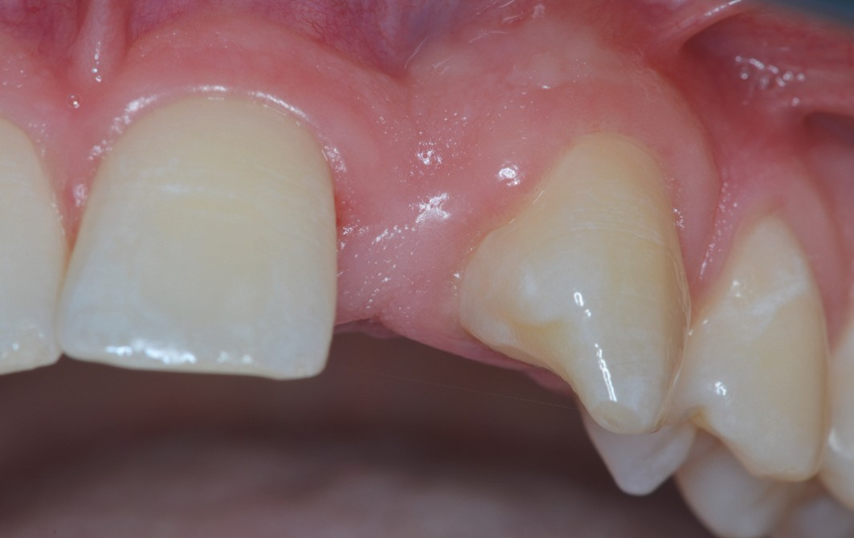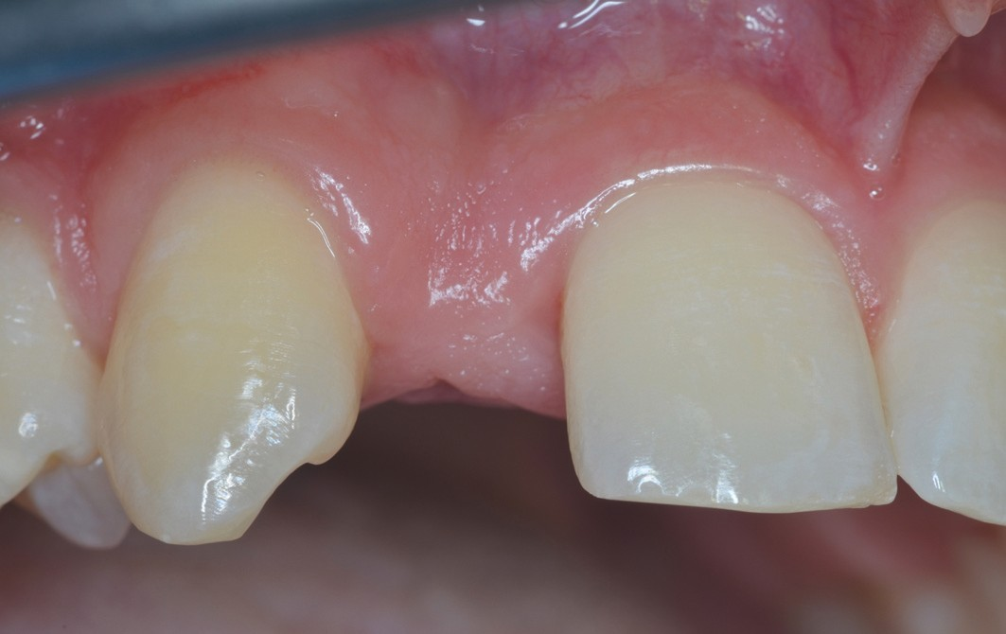
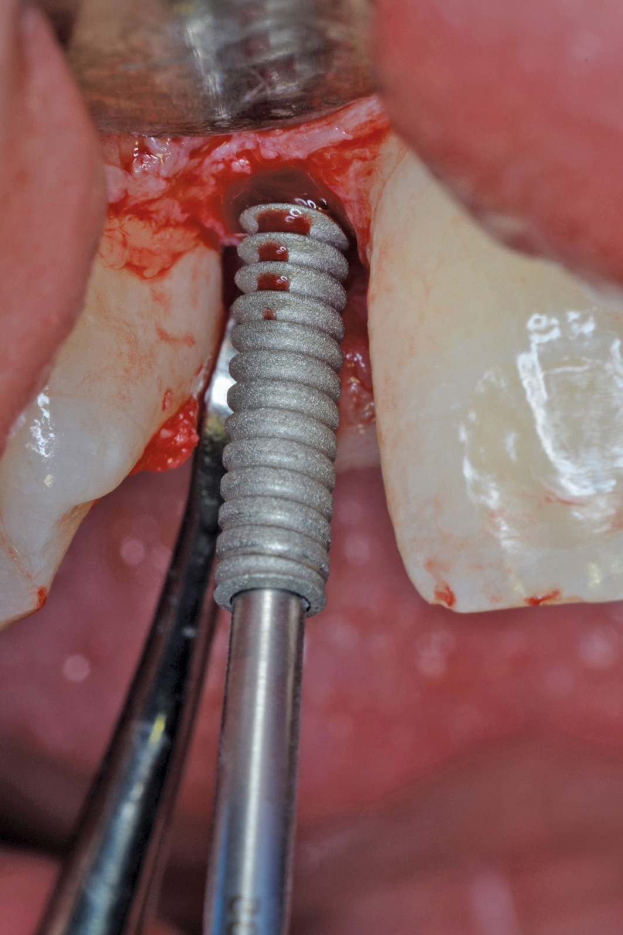
F_{IG}.6 / Pre-operative situation in 22. F_{IG}.7 / Pre-operative situation in 12.
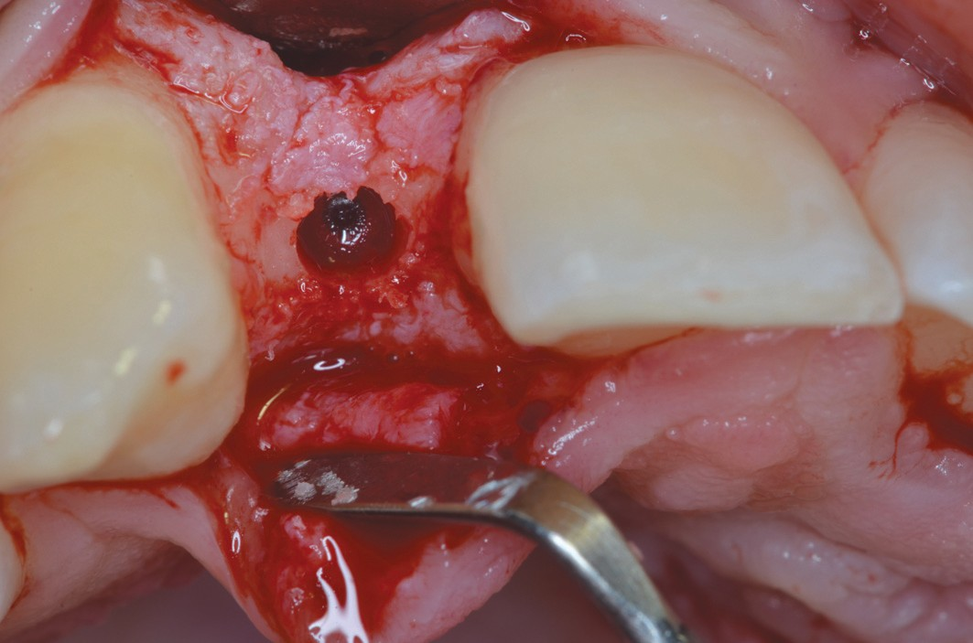
F_{IG}.8 / Implant site.

F_{IG}.9/ Placement of Axiom® 2.8. implant
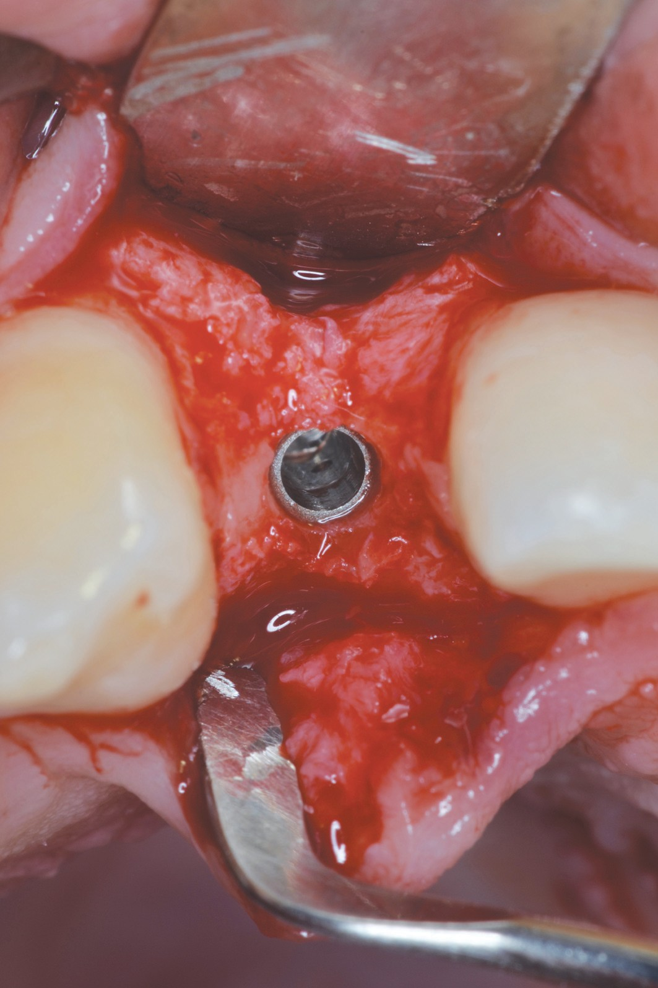
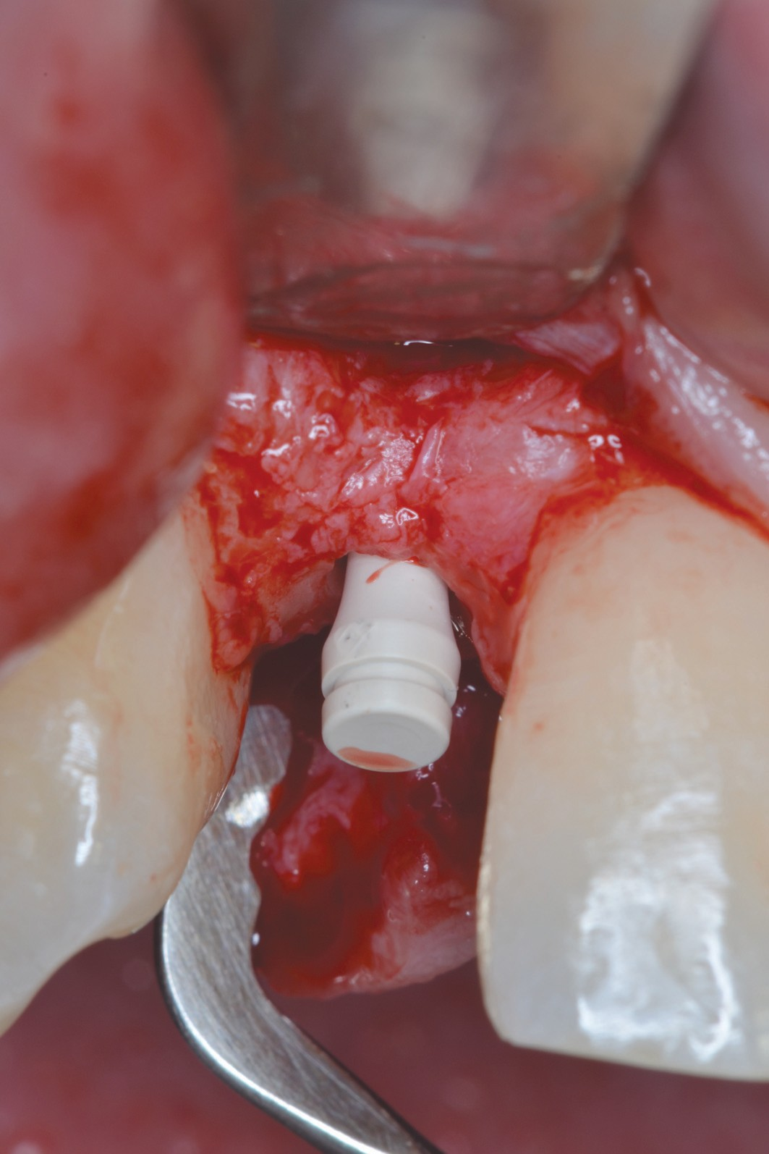
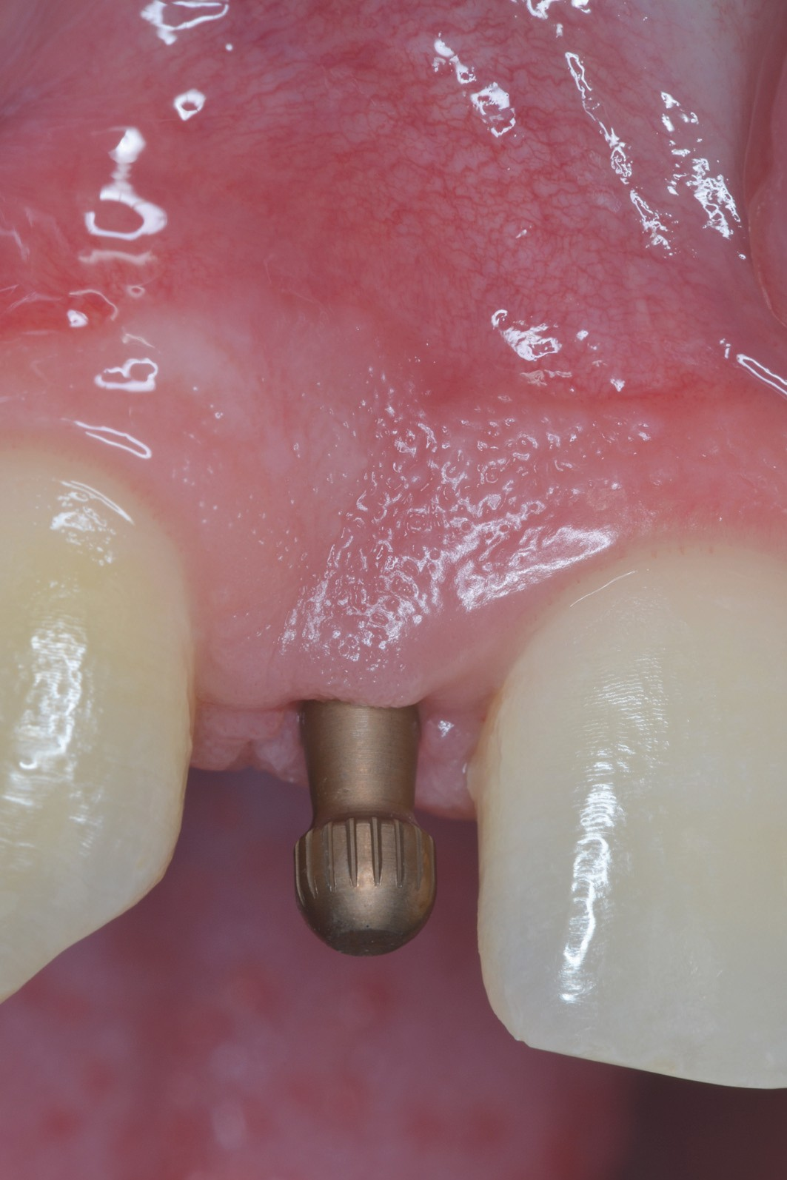
F_{IG}. 10 / Implant placement. F_{IG}. 11 / A Peek healing cap. F_{IG}. 12 / Pop in impression transfer.

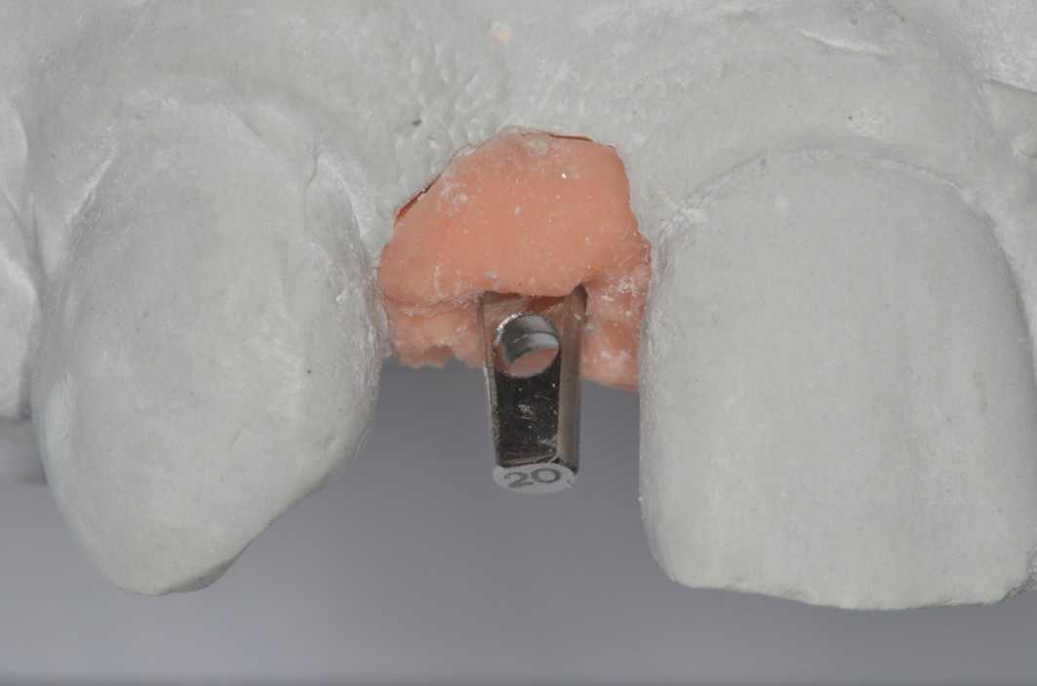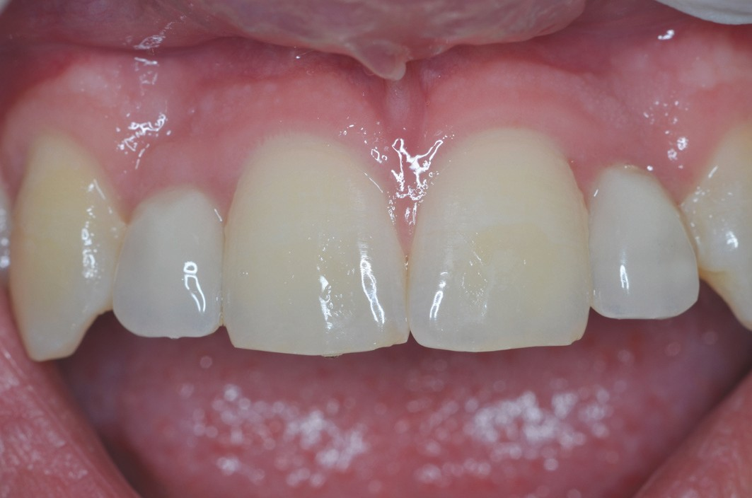
F_{IG}. 13 / Test abutment. F_{IG}. 14 / Temporary prostheses in the mouth.

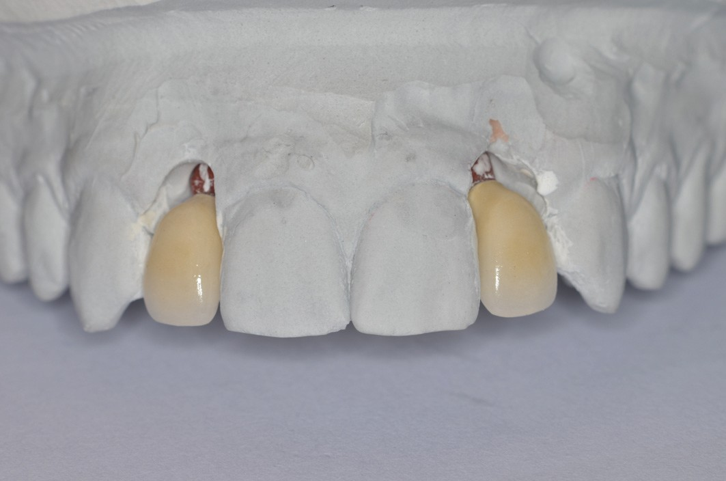
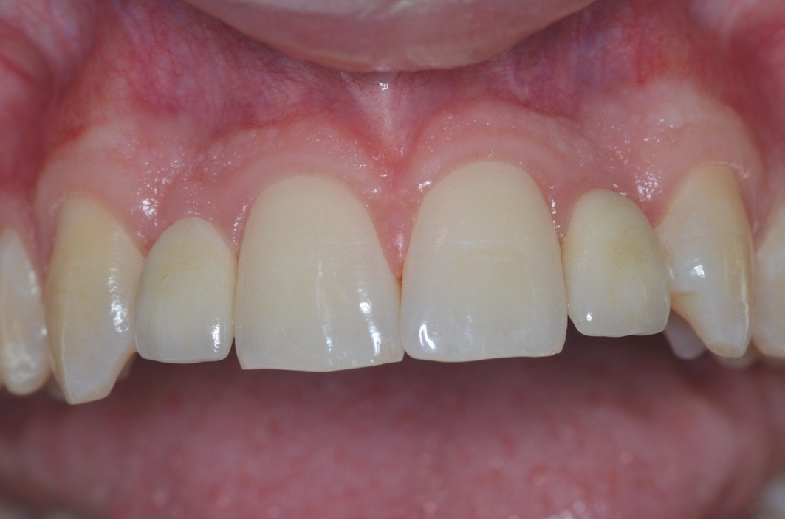
F_{IG}. 15 / Final prostheses on plaster model. F_{IG}. 16 / Ceramic-metallic crowns in place.

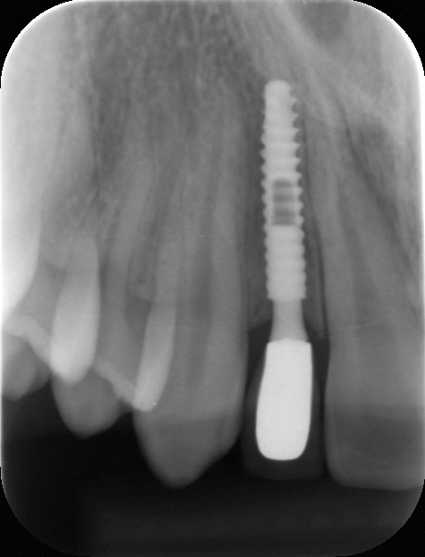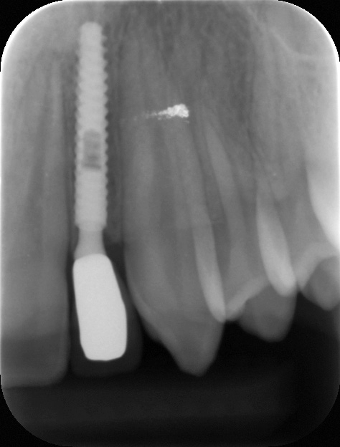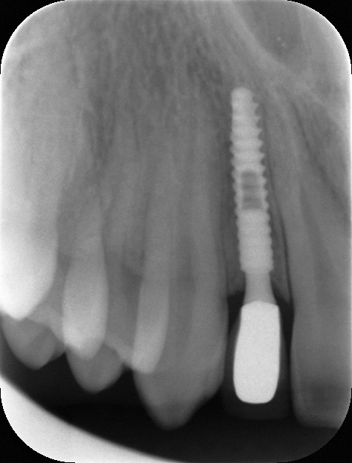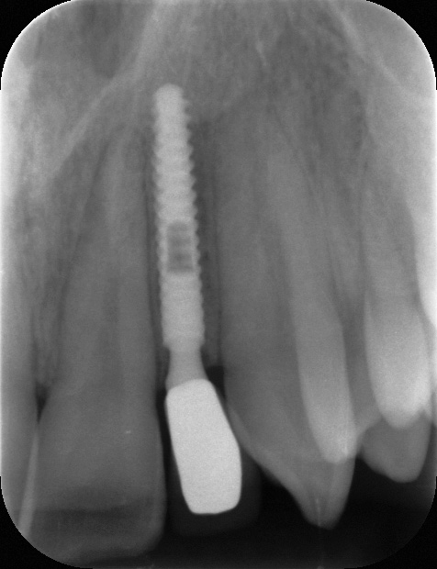

F_{IG}. 17 / Follow-up x-ray of the final prosthesis in 12.
F_{IG}. 18 / Follow-up x-ray of the final prosthesis in 22.
F_{IG}. 19 / Follow-up x-ray of 12, 1 year post-treatment.
F_{IG}. 20 / Follow-up x-ray of 22, 1 year post-treatment.

CASE No. 2 - Dr Patrick EXBRAYAT (_{FIG}. 21 to 35)
Madison G., age 22 years, presentsa major rhizalysis at 22 following the ectopy of 23 and its surgical-orthodontic implantation.

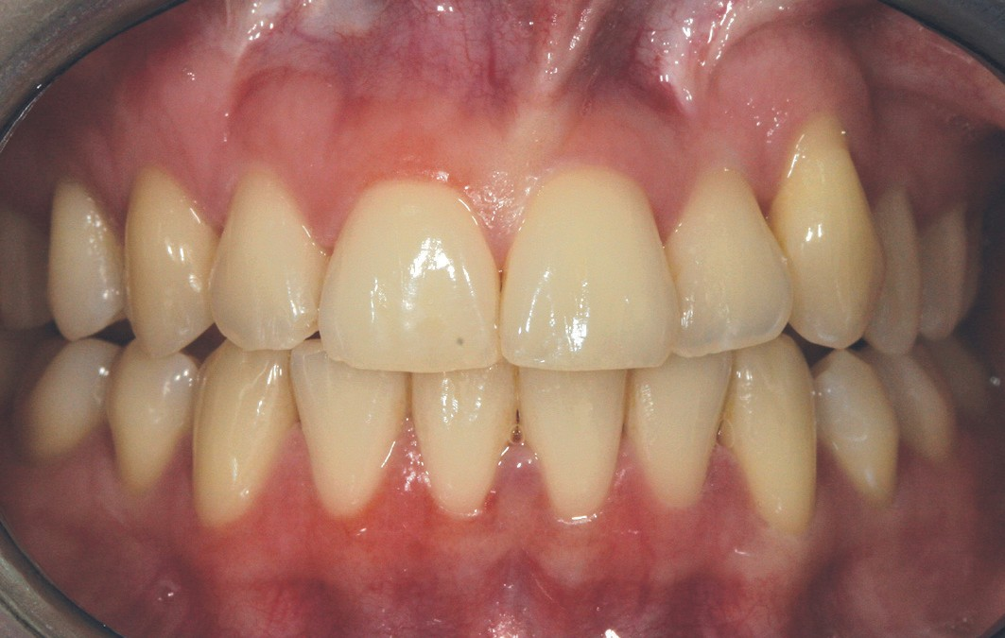
F_{IG}. 21 / Pre-operative clinical view.

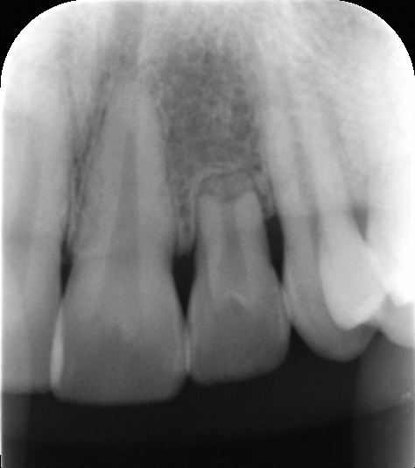
F_{IG}. 22 / Pre-surgical x-ray.

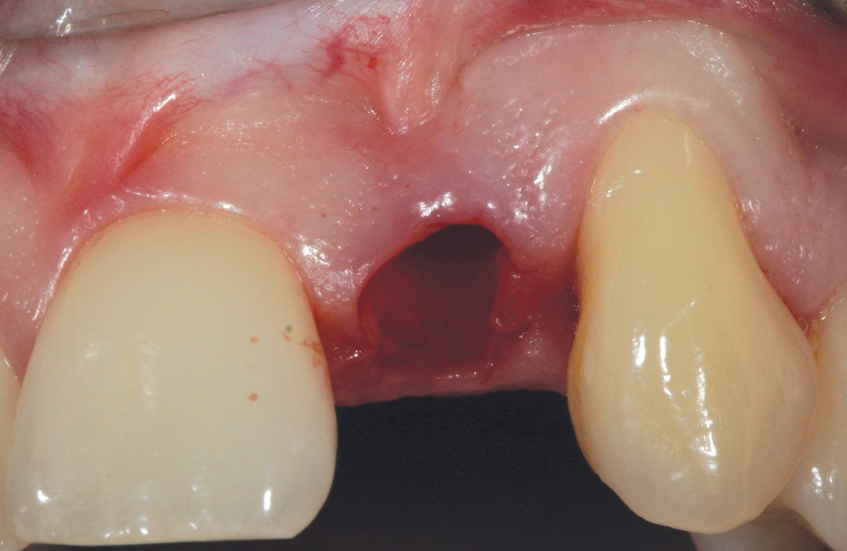
F_{IG}. 23 / Post-extraction site.

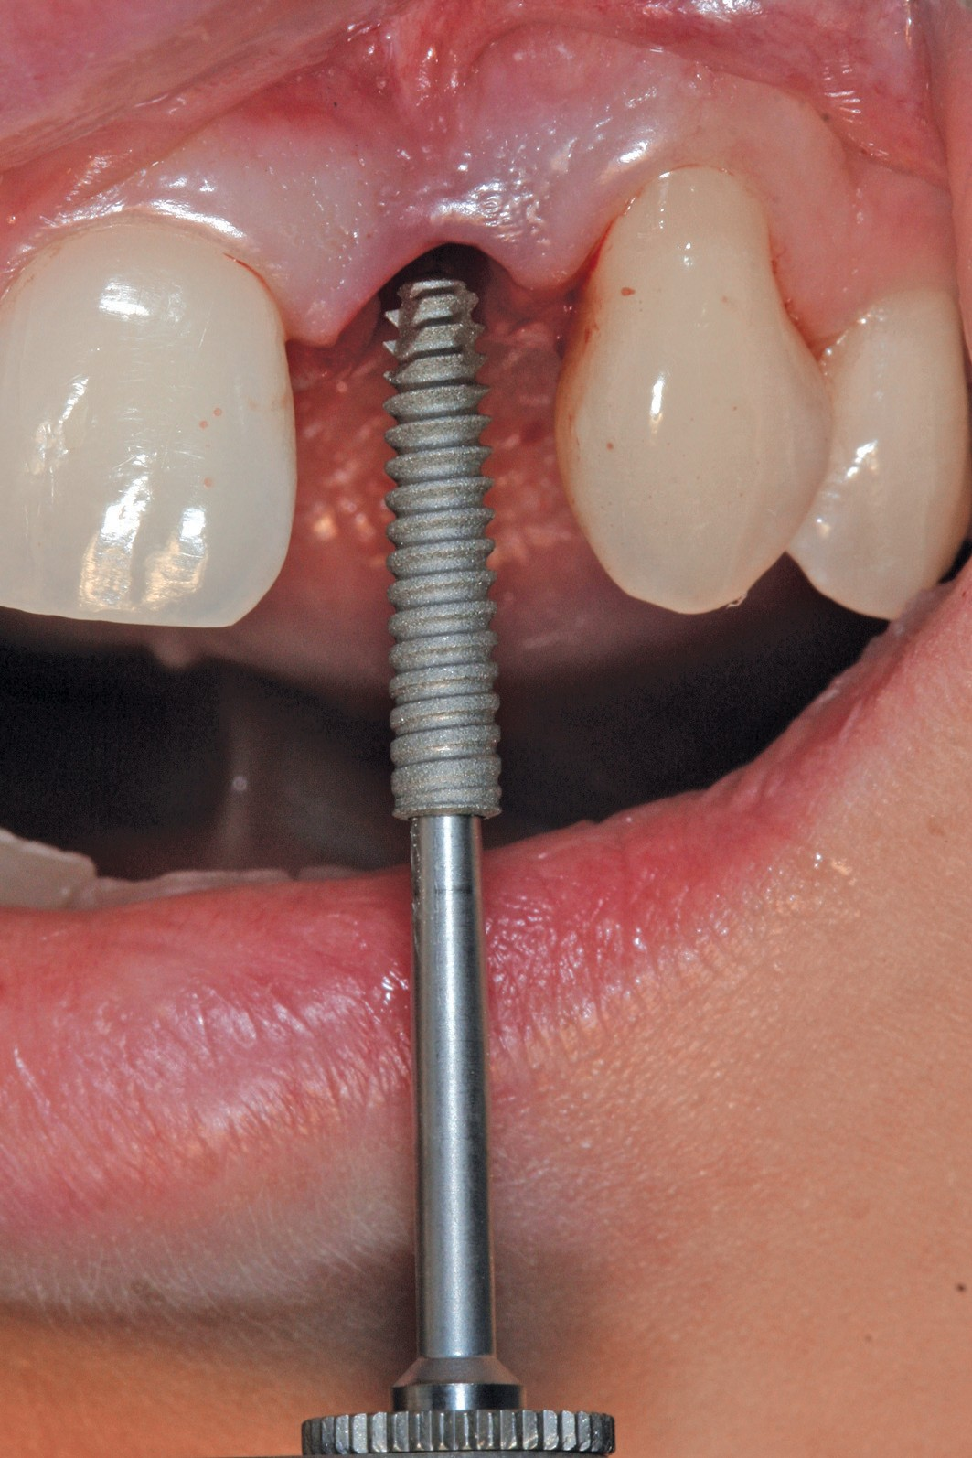
F_{IG}. 24 / Placement of the Axiom® 2.8 x 14 implant.
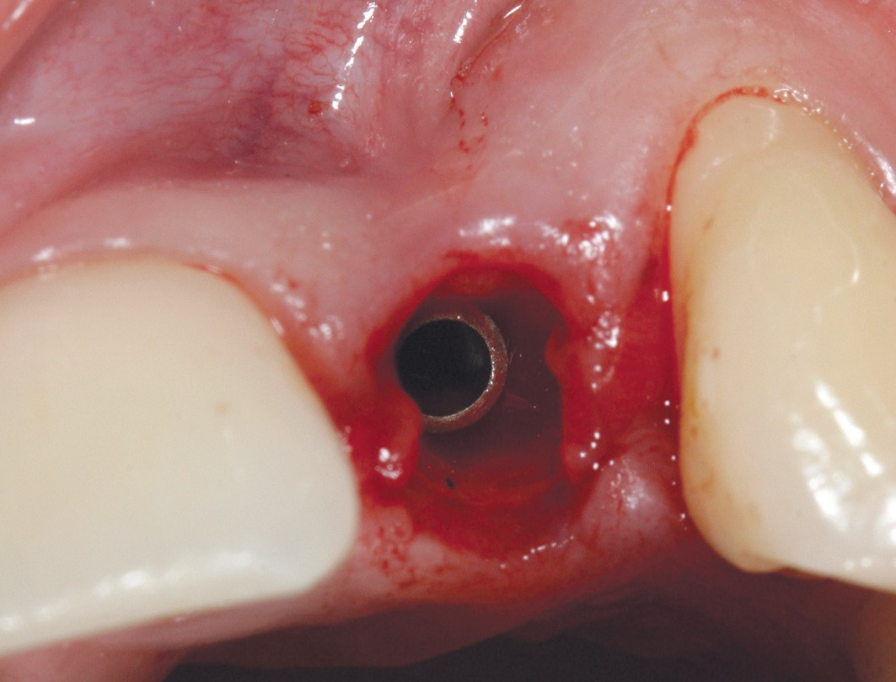
F_{IG}. 25 / Implant in place.
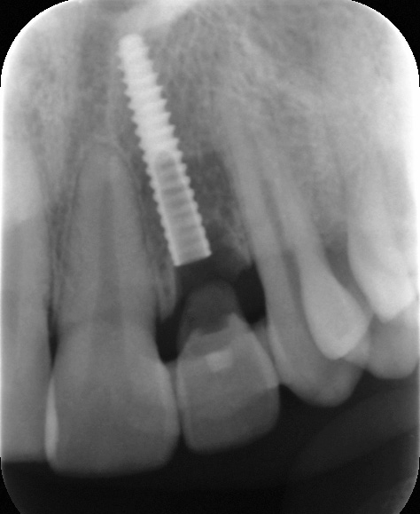
F_{IG}. 26 / Post-surgical x-ray.

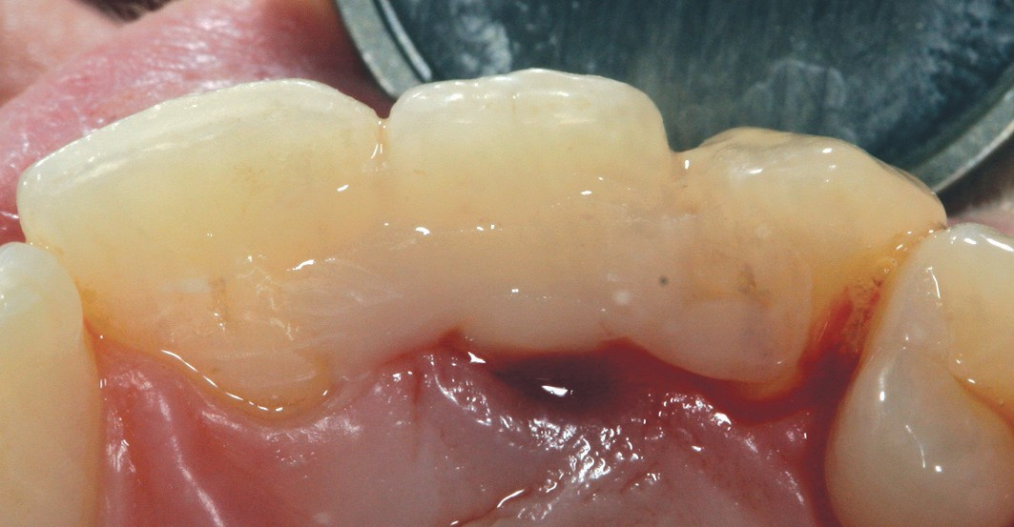

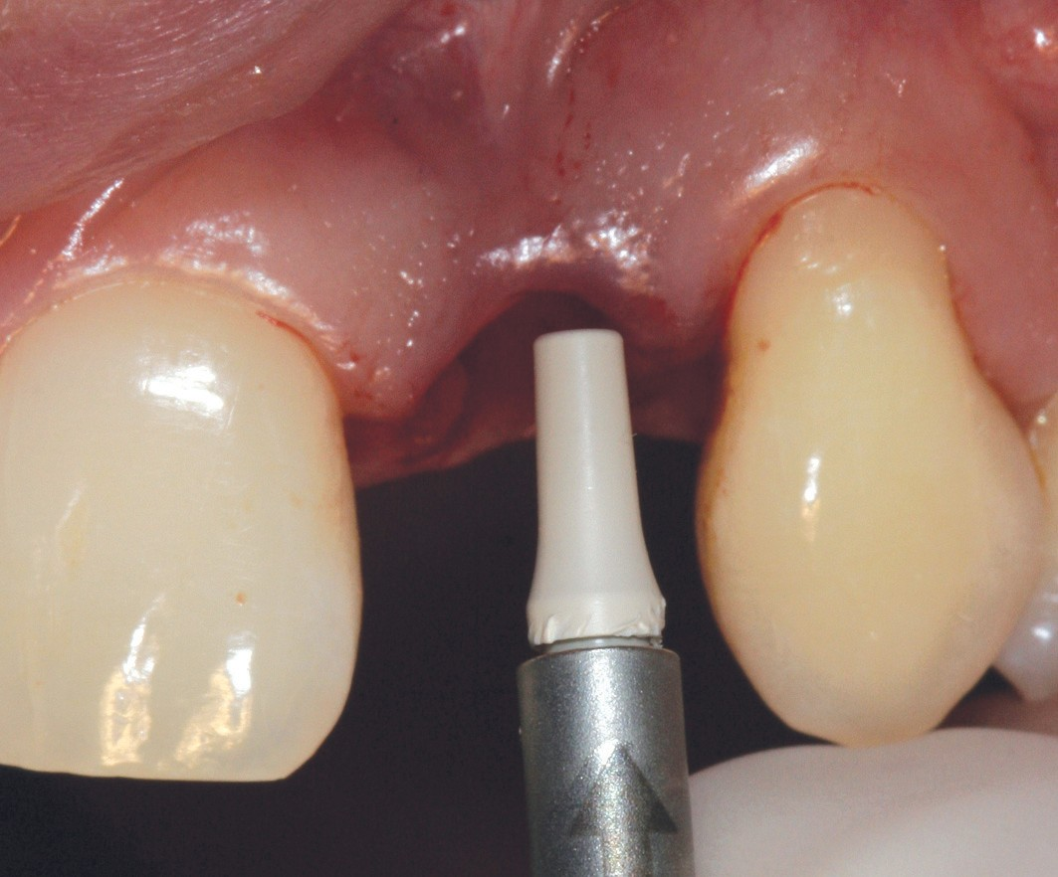
F_{IG}. 27 / Placement of the healing cap.

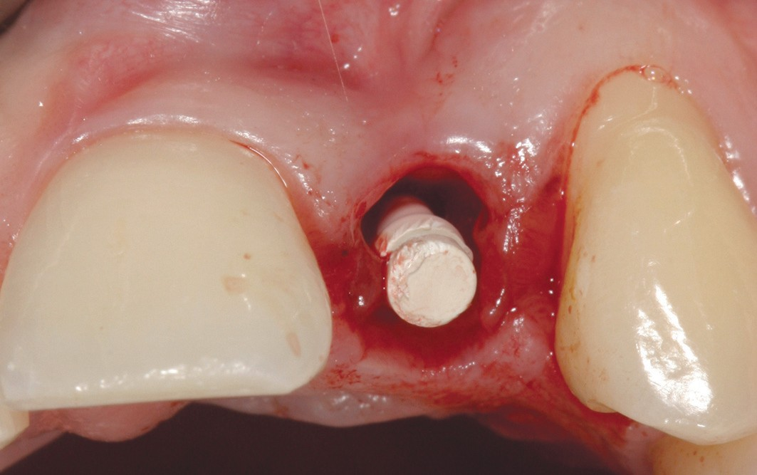
F_{IG}. 28/ Healing cap in place.
F_{IG}. 29/ Cemented temporary prosthesis, palatal view.

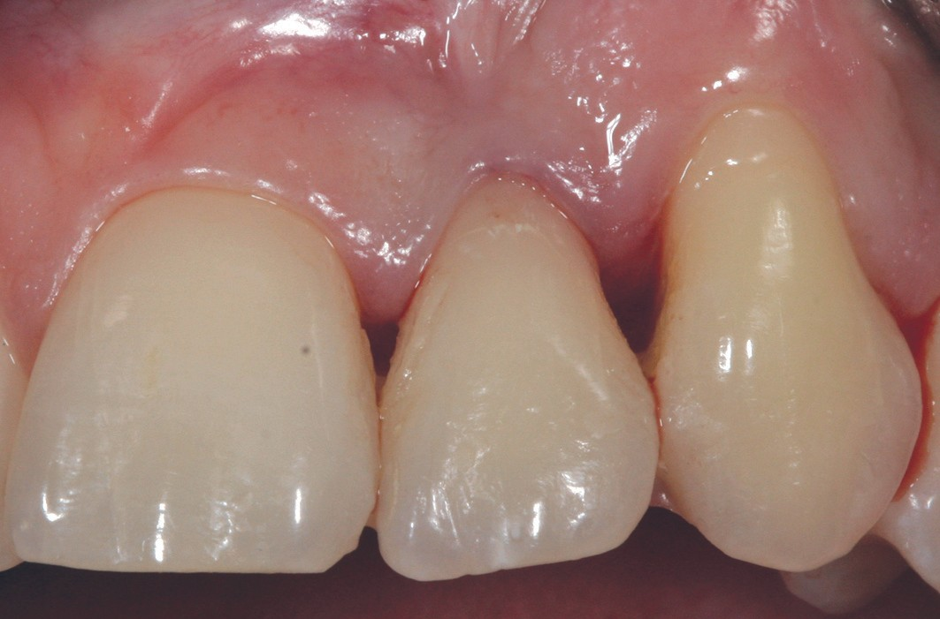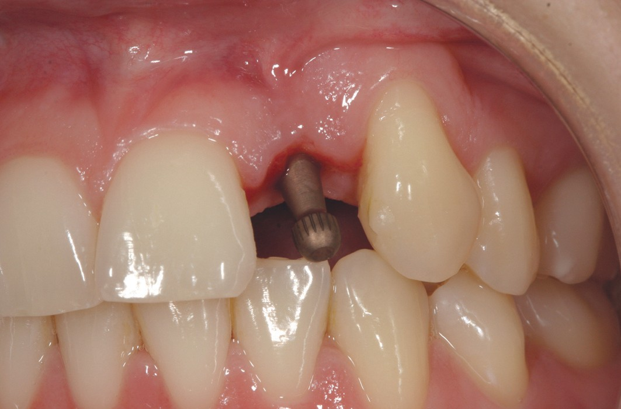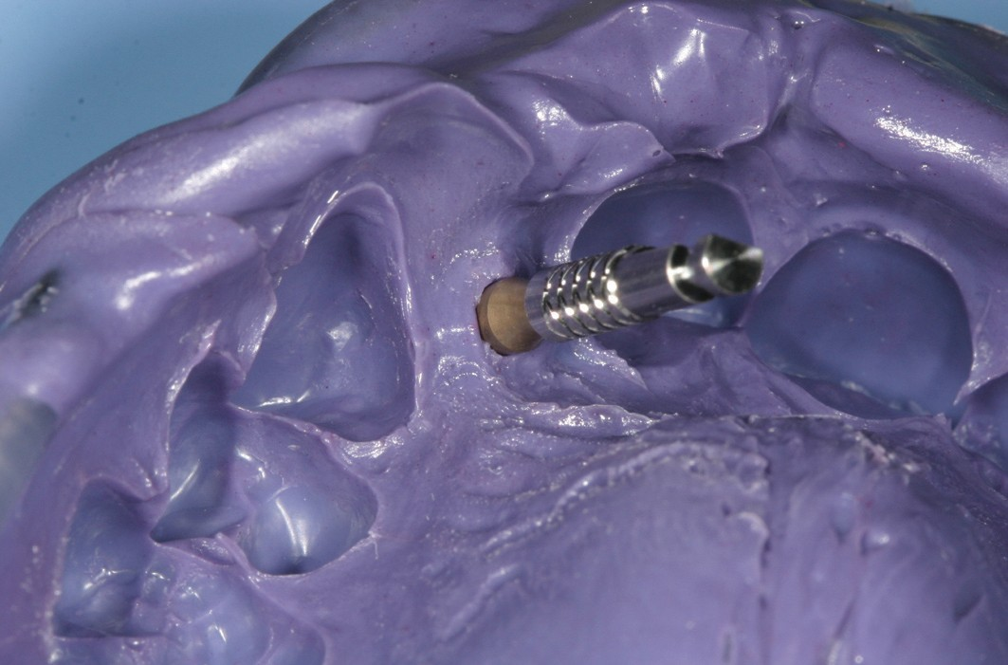

F_{IG}. 30 / Cemented temporary prosthesis, vestibular view.
FIG. 31 / Transfer in place for impression. F_{IG}. 32/ Impression using polyether
material (Impregum®).

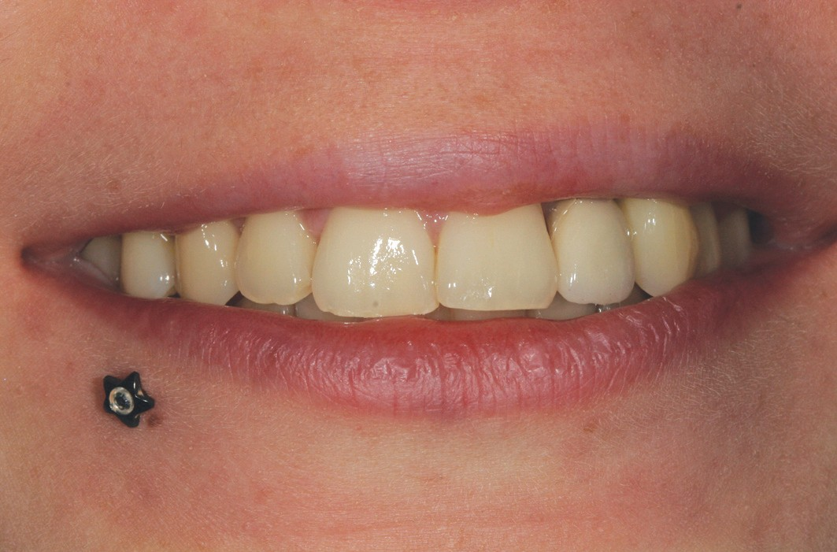

F_{IG}. 33 / Final smile.

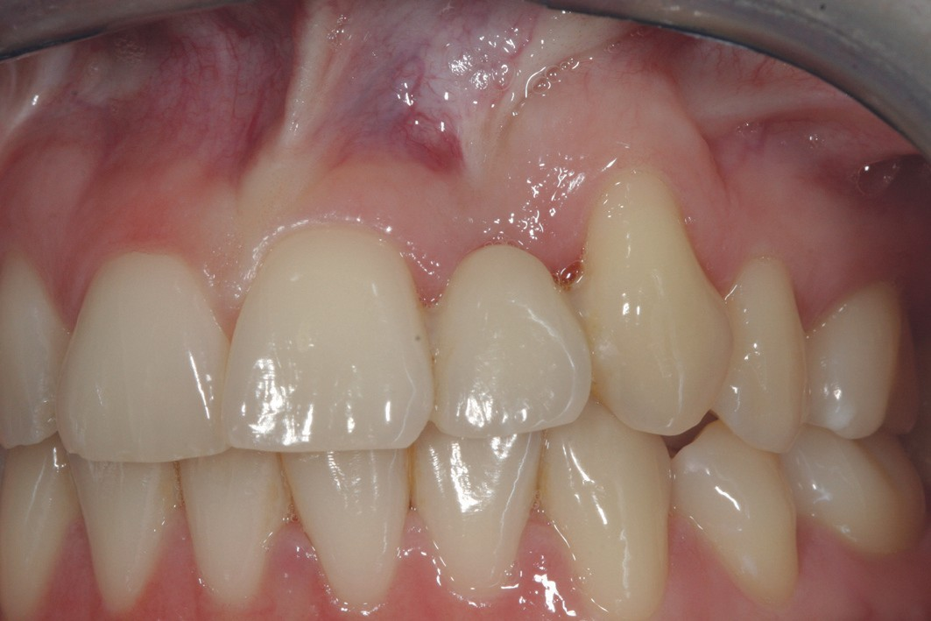
F_{IG}. 34/ Compressive final prosthesis.

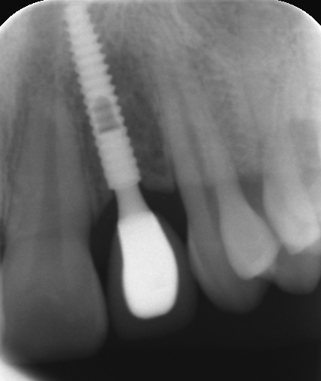
F_{IG}. 35 / Follow-up x-ray after 1 year.

CASE No. 3 -Dr Patrick EXBRAYAT (_{FIG}. 36 to 49)
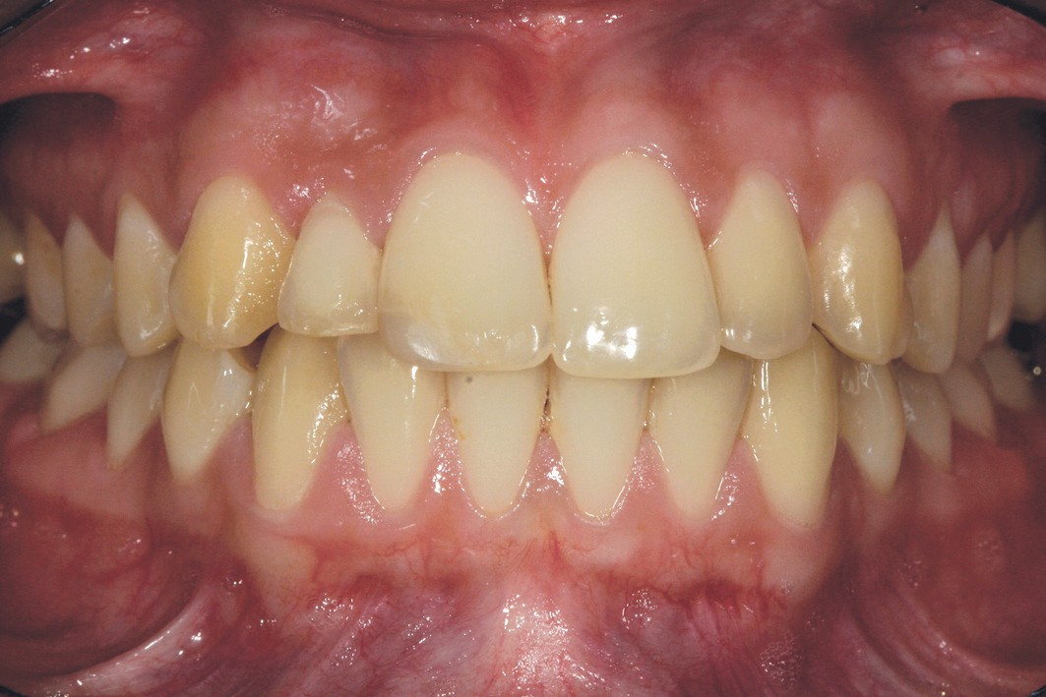
Mélanie D. presents an agenesis at 12 with persistence of the temporary lateral incisor.
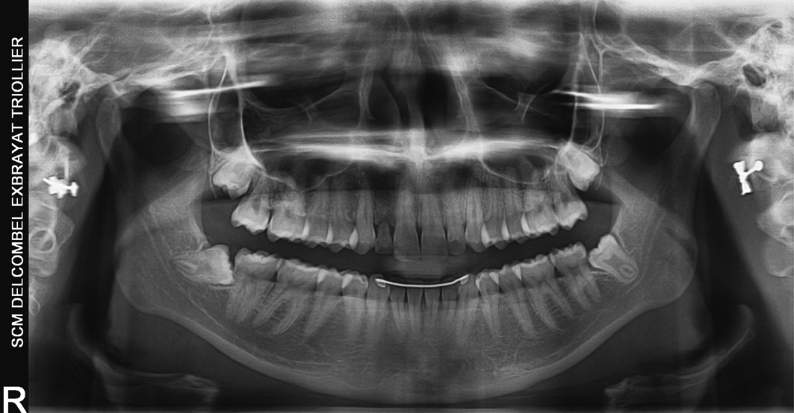
F_{IG}. 36 / Pre-operative panoramic x-ray.

F_{IG}. 37 / Pre-operative clinical situation.
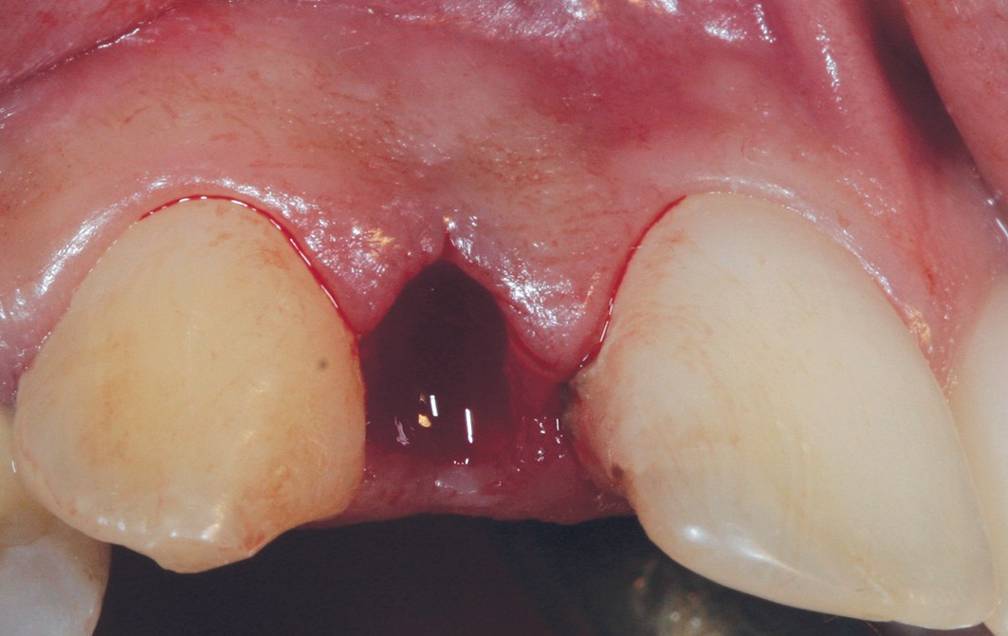
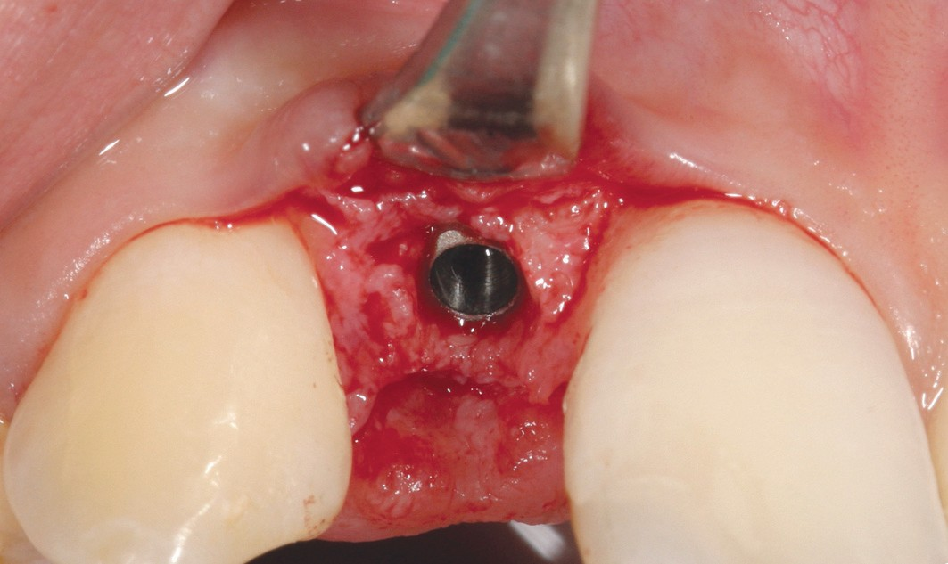
F_{IG}. 38 / Post-extraction implant site. F_{IG}. 39 / Implant in place.

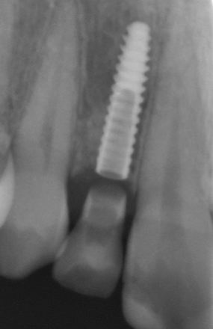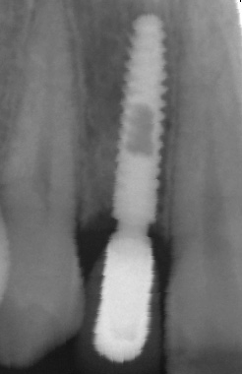

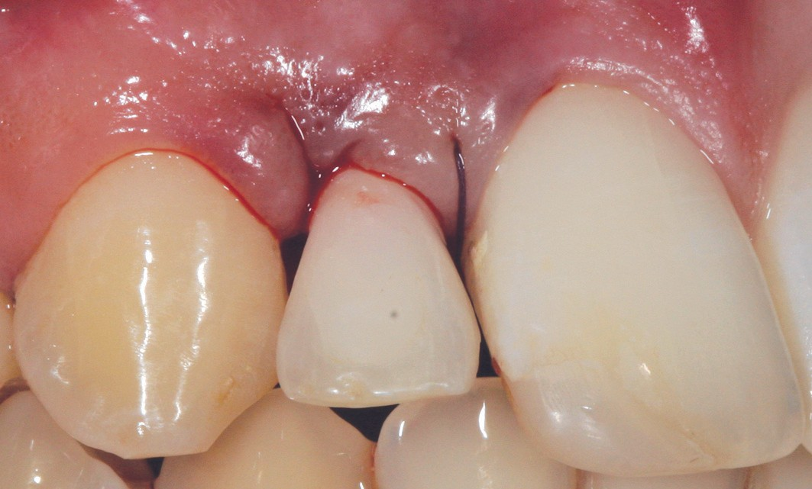
F_{IG}. 40 / Compressive temporary prosthesis.
F_{IG}. 41 / Postoperative retro-alveolar x-ray.
F_{IG}. 42 / Post-prosthetic x-ray.

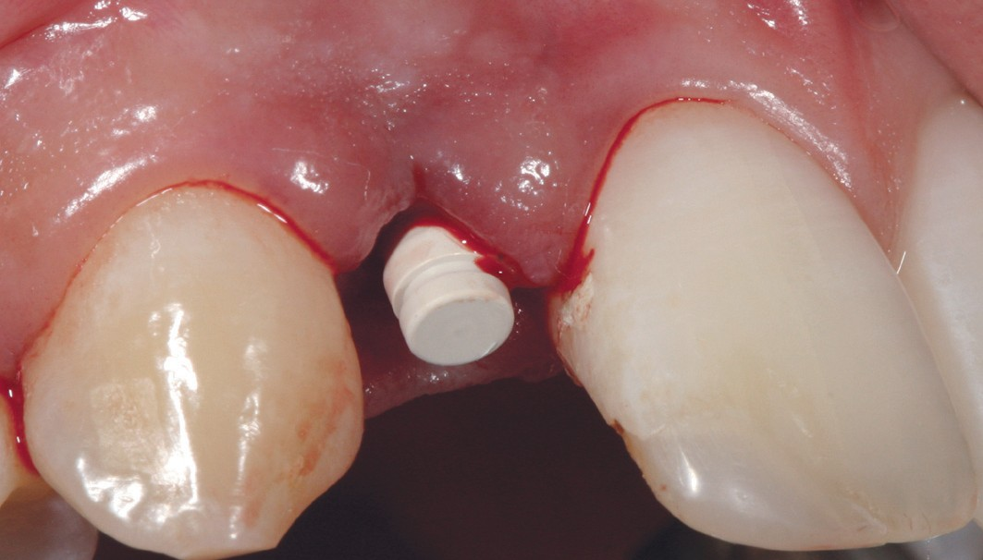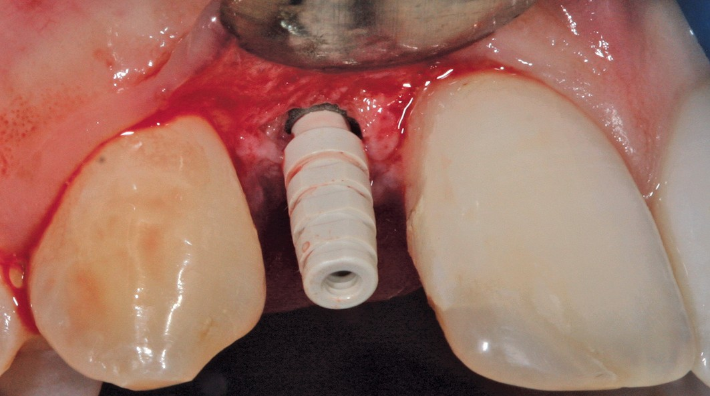
F_{IG}. 43 / Healing cap. FIG. 44 / Temporary abutment.

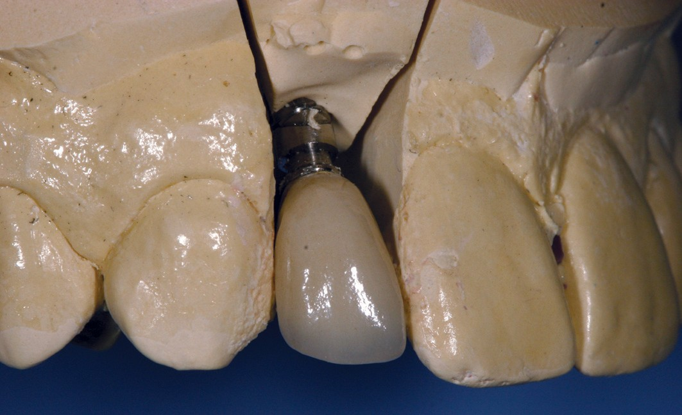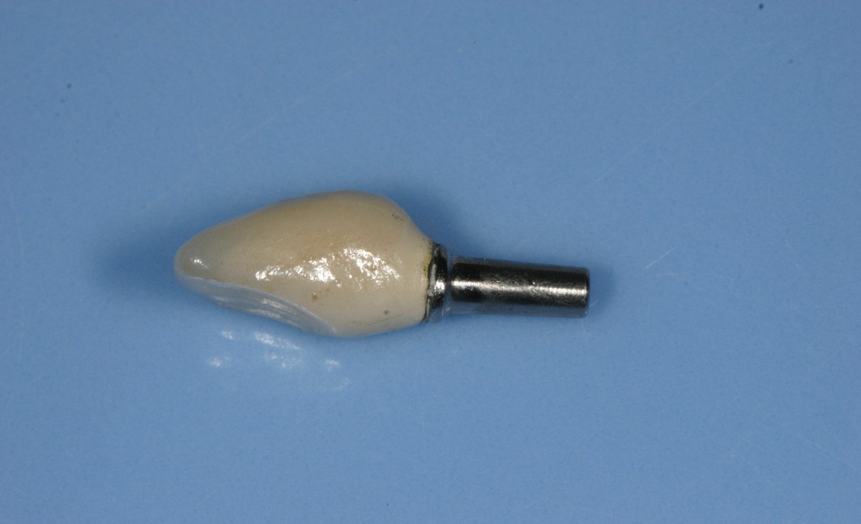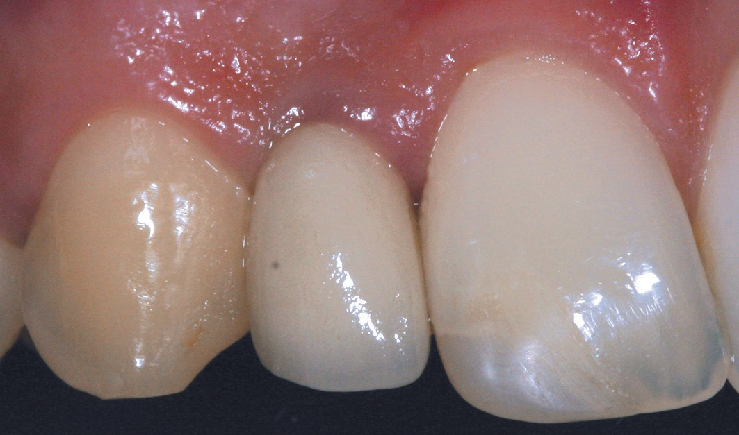

F_{IG}. 45 / Final ceramic-metallic crown.
F_{IG}. 46/ Final ceramic-metallic crown.
F_{IG}. 47/ Final prosthesis in place.

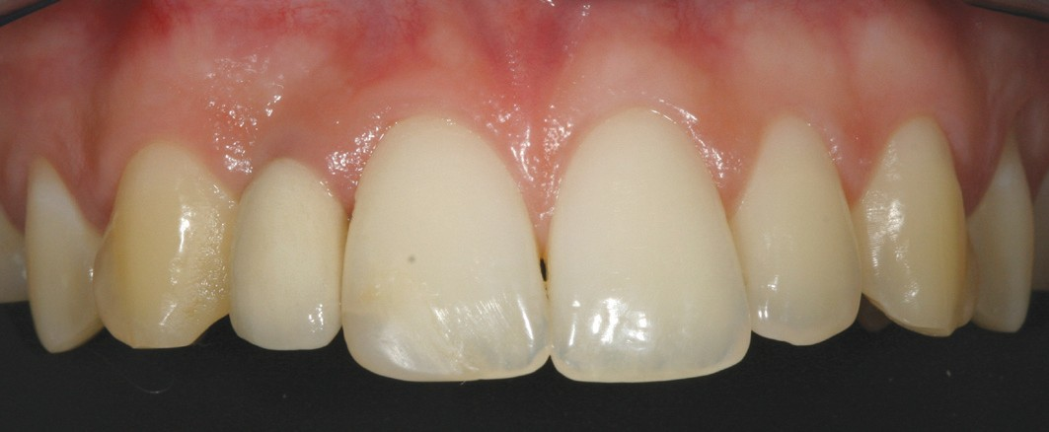

F_{IG}. 48 / Clinical view after 1 year.

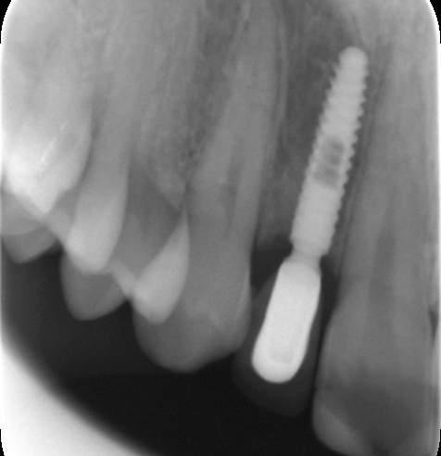
F_{IG}. 49 / Follow-up x-ray after 1 year.

DISCUSSION
Since the publication of the principles of osteointegration by Bränemark et al [1], the evolution of the peri-implant crestal bone level has been considered as one of the principle factors for evaluating the success of dental implants. According to Albrektsson et al [2], the x-ray of a dental implant with an external hexagon should show no peri-implant radiolucent image, and vertical bone loss should be limited to 1 mm in the first year and less than 0.2 mm in the following year. In 1981, Adell et al [3] showed that more than 50% of total bone loss over a 12-month period occurs in the first three months after treatment. Two years later, they found that most bone loss occurred during the 12 months that followed the connection of the abutment [4]. In 2007, Misch et al [5] published a consensus updating the criteria for the success, survival and failure of implants. The James-Misch scale was modified and 4 clinical categories were defined: success, satisfactory survival, compromised survival, and failure. An implant is considered clinically successful if no pain or sensitivity is felt during mastication, if the implant is not mobile, if no exudate is observed and if peri-implant bone loss is less than 2 mm from the moment of implant placement.
If we consider this last criteria, 95% of Axiom® 2.8 implants evaluated 1 year after treatment presented less than 2 mm bone loss and half of the implants presented bone gain. It is therefore possible to conclude that 95% of the implants placed for the purpose of this study have been clinically successful.
With only one implant failure out of the 24 placed, we can also conclude that the implant survival rate observed at 1 year after implant placement is 95.8%. There were no clinical cases of abutment or implant fractures, which confirms that the Axiom® 2.8 titanium alloy implant is dynamically reliable in the selected indications.
Due to its small diameter, the Axiom® 2.8 implant is recommended for narrow interdental spaces,

and specifically for single-unit replacements of maxillary lateral incisors or mandibular incisors.
Barber and Seckinger [6] report that the 2.9 mm diameter implant used in their study is recommended to replace mandibular incisors and in cases where the space between the teeth is less than 5 mm.
Similarly, Vigolo et al [7] report survival rates of 95.3% on 193 implants after 7 years.
The reliability of this type of compressive connection is supported by clinical studies [8-10] and has success rates comparable to those of screw-retained connections, even in cases of narrow diameter implants [11]. The main complications are identical to those for conventional implants, with connector-related problems accounting for less than 0.5% of cases.

CONCLUSION
These preliminary results 1 year after treatment provide a positive conclusion on the clinical effectiveness and 1-year reliability of the Axiom® 2.8 implant. The results at 3 and 5 years will provide a useful complement to these short-term elements!

BIBLIOGRAPHY
- Brånemark PI, Hansson BO, Adell R, Breine U, Lindström J, Hallen O et al. Osseointegratedimplantsinthetreatmentoftheedentulousjaw. Experience from a 10-year period. Scand J Plastic Recontr Surg 1977;16:1-132.
- Albrektsson T, Zarb G, Worthington P, Eriksson AR. The long-term efficacy of currently used dental implants: a review and proposed criteria of success. Int J Oral Maxillofac Implants 1986;1:11-25.
- Adell R, Lekholm U, Rockler B, Brånemark PI et al. A 15 year study of
osseointegrated implants in the treatment of the edentulous jaw. Int. J Oral Surg 1981:10 387-416.
- Adell R. Clinical results of osseointegrated implants supporting fixed prostheses in edentulous jaws. J Prosthet Dent 1983;50:251-254.
- Misch CE, Perel ML, Wang HL, Sammartino G, Galindo-Moreno P, Trisi P et al. Implant success, survival, and failure: The International Congress of Oral Implantologists (ICOI) Pisa Consensus Conference. Implant Dentistry 2008;17:5-15.
- Barber HD, Seckinger RJ. The role of the small-diameter dental implant: a preliminary report on the Miniplant system. Compendium 1994;15:1390-1392.
- Vigolo P, Givani A, Majzoub Z, Cordioli G. Clinicalevaluationofsmall- diameter implants in single-tooth and multiple-implant restorations: a 7-year retrospective study. Int J Oral Maxillofac Implants 2004;19:703-709.
- Mangano C, Mangano F, Shibli JA, Ricci M, Sammons R, Figliuzzi M.
Morse taper connection implants supporting ‘‘planned’’ maxillary and

mandibular bar-retained overdentures: a 5-year prospective multi-center study. Clin Oral Impl Res 2011;22:1117-1124.

Philippe Russe
Diplôme Universitaire Clinique d’Implantologie Chirurgicale et Prothétique (DUCICP), University of Paris VII
University Diploma in Calcified Tissue, Angers Former University Hospital Assistant, Reims Expert at the Court of Appeal of Reims
- Mangano C, Mangano F, Shibli JA, Tettamanti L, Figliuzzi M, d’Avila S, Piattelli A. Prospective evaluation of 2,549 Morse taper connection implants: 1- to 6-year data. J Periodontol 2011;82:52-61.
- Mangano C, Iaculli F, Piattelli A, Mangano, F. Fixed restorations supported by Morse-taper connection implants: a retrospective clinical study with 10-20-years of follow-up. Clin Oral Implants Research 2015;26:1229-1236.
- Mangano F, Shibli JA, Sammons RL, Veronesi G, Piattelli A, Mangano C. Clinical outcome of narrow-diameter (3.3-mm) locking- taper implants: a prospective study with 1-to 10-years of follow-up. Int J Oral Maxillofac Implants 2014;29:448-455.
Bibliographic references
This article may be searched or cited under the following reference: Exbrayat P, Missika P, Russe P. Clinical evaluation of the 2-part Axiom® 2.8 implants. Results 1 year post-treatment for a multicentre clinical study Implant 2018;24:49- 61.

Patrick Exbrayat
Senior University Lecturer, Hospital practitioner in Lyon
Director of the University Degree in Periodontology and Oral Implantology in Lyon
Expert at the Court of Appeal in Lyon

Patrick Missika
Senior University Lecturer, Diderot University in Paris, Associate Professor at the Tufts University in Boston
Expert at the Court of Appeal in Paris
National expert approved by the Court of Cassation
Patrick Exbrayat
Senior University Lecturer
Hospital practitioner in Lyon
Director of the University Department in Periodontology
and Oral Implantology in Lyon
Expert at the Court of Appeal in Lyon

POINTS OF INTEREST: Anthogyr (Sallanches, France), manufacturer of the implants used in this study, partially funded this clinical study and donated the implants and prosthetic components; however, the data is the property of the authors and under no circumstances did the sponsor interfere with the conduct of the study or the publication of its results.

