Insert Company logo here | Dental Practice
Insert Company logo here | Street
Insert Company logo here | City
Insert Company logo here | Postcode
Insert Company logo here | Web

Example of a surgical consent form for dental implantation

Planned treatment:
Implants in: Upper jaw / Lower jaw
Front teeth area / Side teeth area
Left / Right
Implants will be placed as indicated on this chart:
Upper Jaw | 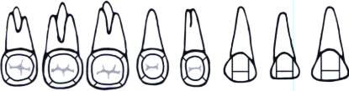 |  |  |  |  |  |  |  | 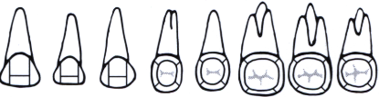 |  |  |  |  |  |  |  | Upper Jaw
R | 18 | 17 | 16 | 15 | 14 | 13 | 12 | 11 | 21 | 22 | 23 | 24 | 25 | 26 | 27 | 28 | L
R | 48 | 47 | 46 | 45 | 44 | 43 | 42 | 41 | 31 | 32 | 33 | 34 | 35 | 36 | 37 | 38 | L
Lower Jaw | 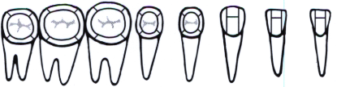 |  |  |  |  |  |  |  | 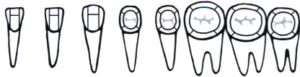 |  |  |  |  |  |  |  | Lower Jaw
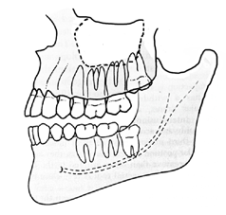
I understand that these are the complications of the proposed treatment and this list may not be complete:
More common complications such as:
- Pain
- Swelling
- Bleeding
- Bruising
- Infection

Other potential complications are:
- Wound-healing difficulties such as dry socket
- Soft-tissue injury
- Restricted opening of the mouth
- Damage to neighboring teeth and/or existing restorations
- Fractured root tips or jaw bone
- Loss of sensation in teeth, lips, tongue and surrounding tissue which can last for an indefinite period of time due to possible damage to the lingual nerve (sensory nerve in the tongue) and/or the inferior alveolar nerve (sensory nerve in the lips)
- Perforation of the maxillary sinus and infection of the sinus space can also occur after treatment in the upper jaw

Other warnings explained:

Additional medical risks explained:

I have been adequately advised about my condition, and alternatives to the removal of my tooth/teeth have been explained. The consequences of no treatment have also been explained. The necessity and nature of the planned operation have been explained comprehensively to me by the undersigned dentist. In addition, I have been advised not to operate a vehicle or any machinery and refrain from physical exertion on the day of the operation.
I have been given the opportunity to ask questions and have them fully answered. I have no further questions, and I give my consent to undergo the planned intervention.

(city) , on ( date )

Patient

Dentist

